Setting Up Extended Time Accommodations for Blackboard Exams

If at any point in this process you have questions regarding:
- Blackboard – please contact Syracuse University ITS at help@syr.edu or the IT contact within your School or College
- A student registered with our office – please contact either the Disability Access Counselor listed on the student’s Accommodation Letter or the main office at disabilityresources@syr.edu
- The Office of Disability Services in general – please contact the main office at disabilityresources@syr.edu

- When setting up your exam in the Test Settings section, locate the Test Availability Exceptions section, click on Add User or Group, select the student needing extended time, and click Submit.
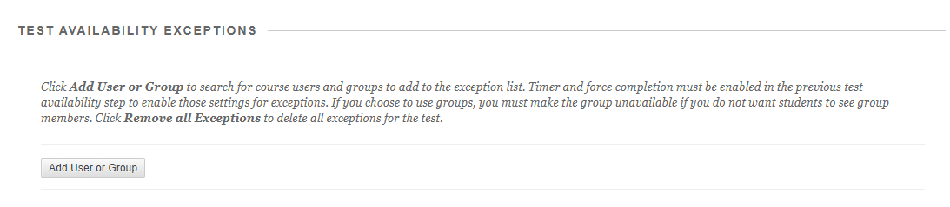

- In the Attempts column, select the drop-down menu to choose between Single Attempt, Multiple Attempts, or Unlimited Attempts. If Multiple Attempts is selected, enter the number of attempts.
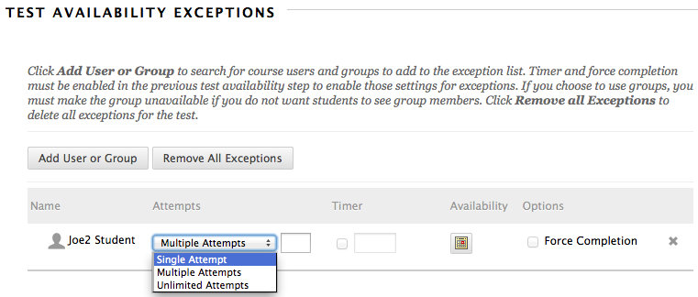

- In the Timer column, check the box and enter the amount of time (in minutes) that you would like to allow for this student or group.
  - For example, if your regular given time for the exam is 80 minutes and the student has 1.5x, you would type 120 into the box (80 x 1.5 = 120). If the student has 2x, you would type 160 into the box (80 x 2 = 160).
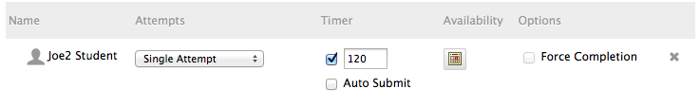

- In the Availability column, select the dates you would like the test to be available for the specific student or group and click Save.
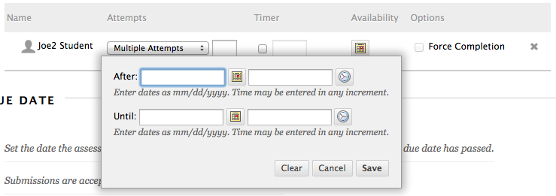

Tips to make the exam more accessible:
-In test presentation make sure all at once is selected so students can see all the questions and are able to go back to old questions.
Resources for help when creating exams in Blackboard:
Blackboard Help
Creating and Deploying Tests in Blackboard 14:20

How to import test questions into Blackboard 9:56
Creating a Quiz in Blackboard 10:06

