Accessible Apps for College Students

Table of Contents
Text-to-speech 1
Voice Reading: 1
NaturalReader: 1
Easy Text To Speech 1
Voice Dream Reader 2
Capti Voice 2
Voice-to-text 2
Dragon Search 2
Dragon Mobile Assistant 3
SoundNote 3
Note Taking 3
Fast Finga 3 3
Evernote 3
AudioNote 4
iAnnotate 4
Cogi Note and Voice Recorder 4
One Note 5
Notability 5
Epub Reading 5
BeeLine Reader 5
VI Reader 6
Writing 6
ProWritingAid 6
Note Everything 6
Mindfulness 6
Mindshift 6
Calm 7
Headspace 7
Simple Habit 7
Aura 7
Study 8
Flashcards by Chegg 8
Quizlet 8
Organization 8
Finish. The app for procrastinators 8
iStudiez Pro 9
inClass 9
MyStudyLife 9
School Assistant 9
myHomework 10
RescueTime 10
Google Task 10
Education 10
Syracuse University Mobile 10
Blackboard Mobile Learn 11
Adobe Reader 11
inkling 11
Formulas - Formulas for Calculus 11
Calculus Formulas 12
File Storage 12
Dropbox 12
Dropbox 12
Accessibility 12
Raz Mobility 12
Tecla Access 12

Text-to-speech

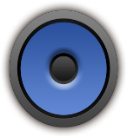

Voice Reading:
Using the Android share feature you can send any data from other apps to Voice Reading.
Device: Android 2.2 and up
Cost: Free
Download from Google Play Store
Rating: 4.1 out of 5

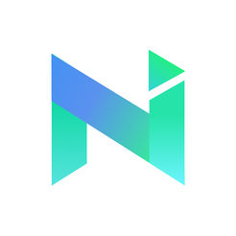

NaturalReader:
Is a text-to-speech app that reads webpages, documents, and eBooks aloud to you with our quality, natural-sounding voices.
Devices: iOS 9.0 or later, Android 4.1 and up, PC Windows XP/7/8/10
Cost: Download Free, has an In-App Purchase $9.99
Download from Apple App Store, Google Play Store, or online at https://www.naturalreaders.com/index.html
Rating: 3.5 out of 5

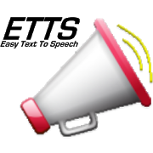
Easy Text To Speech - Automatically speaks the Clipboard, Shared Links and Web Pages. Copy text from any Android application or web browser and hear it instantly spoken back to you. No need to switch applications and no extra clicks. Integrated Web Page and News Article Reader, Clipboard Manager Database storage and many highly productive useful flexible features.
Devices: Android varies with device
Cost: Free
Download from the Google Play Store
Rating: 3.9 out of 5

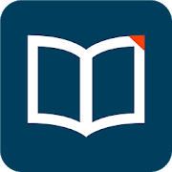
Voice Dream Reader – an accessible text – to – speech reading tool for mobile and tablet devices. This app has a highly configurable screen layout that can be tailored to suit every reading style.
Devices: iOS 9.0 or later, Android 4.3 and up,
Cost: $9.99
Download from the Google Play Store
Rating: 3.7

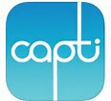

Capti Voice - Text-To-Speech software that reads Word documents, PDFs, webpages, and more.
Has numerous voices to select from.
Devices: iOS 9.0 or later PC Windows 7 or later, MAC El Capitan or later.
Cost: Download is free. Premium voices are subscription based with the pricing determined by length of subscription.
Download Apple App Store or online at https://www.captivoice.com/capti-site/
Rating: 4 out of 5

Voice-to-text

Dragon Search – search online using only your voice
Device: iOS 4.0 or higher
Cost: Free
Download from the Apple App Store
Rating: 2.6 out of 5

Dragon Mobile Assistant - Hands-Free navigation, allows you to search online, send/receive text messages/emails, etc.
Device: Android 4.0 and up
Cost Free
Download from Google Play Store
Rating4.5 out of 5

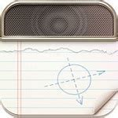
SoundNote - takes notes in meetings, lectures, and interviews. It tracks what you type and draw while recording audio, so you’ll never worry about missing an important detail. During playback, just tap a word: SoundNote will jump right to the proper time in the audio
Devices: iOS 9.3 or later
Cost: $4.99
Download from Apple App Store
Rating: 4+

Note Taking

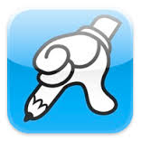
Fast Finga 3- Converts hand written notes into text
Device: iOS 8.4 or later
Cost: Free
Download from Apple App Store
Rating: 3.5 out of 5

Evernote - Stay Organized-Take notes, capture photos, create to-do lists, record voice reminders, searchable.
Devices: iOS 10.3 or later, Android varies with device, PC Windows 10 version 14393.103 or higher
Cost: Free;
Download from Apple App Store, Google Play Store, and the Evernote website link; https://evernote.com/download
Rating: 4.6 out of 5 (Android) 4.0 out of 5 iOS

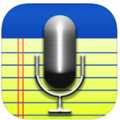
AudioNote - A combined note taking and voice recording app that automatically indexes your meetings, lectures, classes, interviews.
•Take notes linked to recorded audio
•Text, handwritten, & photo notes
•Tap notes and seek directly within audio
•Highlighted notes during playback
Devices: iOS 10.0 or later, Android 2.1 and up, PC Windows versions: XP, Vista, 7, 8, & 10 MAC
Cost: iOS 14.99, iOS Lite – Free, Android $5.99, Android Lite - Free
Download from Apple App Store, Google Play Store, and from the Lumiant Software http://luminantsoftware.com/iphone/audionote.html
Rating: iOS AudioNote 4.5, AudioNote lite 4+, Android AudioNote 3.6, AudioNote Lite 3.6

iAnnotate - Read, annotate, and share PDFs. Improve your productivity and organization
Devices: iOS 9.0 or later
Cost: $9.99
Download from Apple App Store
Rating: 4 out of 5

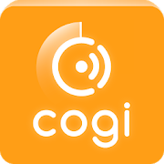
Cogi Note and Voice Recorder – a notetaking and voice recording app that records on the important parts of conversation and allows you to add images, hashtags and text notes.
Devices: Android 4.0.3 and up
Cost: Free
Download from Google Play Store
Rating: 4.0 out of 5

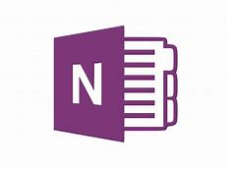
One Note - Note taking software in which the user can hand write or type in their notes.
Drawing, screen shots, and audio can also be added to the notes.
Notes can be shared with other users and co-workers using OneNote
Devices: iOS 10.0 or later, Android 4.4 and up, PC Windows 10 version 1040
MAC
Cost: Free
Download from Apple App Store, Google Play Store, and Microsoft Store
Rating: iOS 4.7 Android 4.4

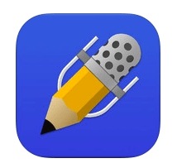
Notability - Note taker that allows the user to create notes: these can include plain text ad drawings and sound recordings.
Devices: iOS 10.0 or later
Cost: $9.99
Download from Apple App Store
Rating: 3.9 out of 5

Epub Reading

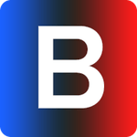
BeeLine Reader - A digital reading technology that uses gradient colors to guide the readers eyes more efficiently over text increasing speed and accuracy.
Devices: iOS 9.0 or later. Google Chrome extension Version: 2.3.0
Cost: Free version allows you to read a set number of pages per day.
Paid subscriptions increase that number.
Download from the Apple App Store and at BeeLine website; http://www.beelinereader.com/
Rating: 3.2 out of 5
Comment: For those with usable vision who can see colors

VI Reader - An epub, ebook reader for visually impaired and dyslexic readers. Allows user to adjust text size, foreground and background colors as well as adjust brightness.
Devices: iOS 8.1 or later, Android 4.0 and up
Cost: Apple App Store and Google Play Store
Download from
Rating: 3.9
Comment: An ebook reader that allows the user to customize the text size, color scheme, and brightness levels.

Writing

ProWritingAid - can help you write papers and assists with spelling and grammar. You can upload word documents or type directly into the program to get started. The program checks for overused words, the overall readability and structure of your papers.
Cost: Free also subscription plans for 1 year, 2 years, 3 years, and lifetime.
Free web based access at https://prowritingaid.com/.

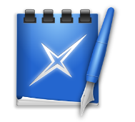
Note Everything - A note (notepad) application where you can create text-, voice- and paint-notes fort Android
Devices: Android varies with device
Cost: Free
Download from Google Play Store
Rating: 4.4 out of 5

Mindfulness

Pacifica is an app for stress, anxiety, and depression based on Cognitive Behavioral Therapy, mindfulness, and wellness. Comprised of quick activities alongside a supportive community, Pacifica is designed as a daily tool to help people address stress, anxiety, and depression at a gradual pace.
Devices: iOS 6.0 or later and Android 4.4 and up
Cost: Free with SUNetID
Download from the Apple App Store and Google Play Store
Rating: iOS 4.7, Android 4.4

Mindshift - This is an app that provides strategies about how to approach anxiety, improve sleep, and change your thinking. It provides helpful tools to coach yourself through stressful situations.
Devices: iOS 6.0 or later and Android 4.4 and up
Cost: Free
Download from the Apple App Store and Google Play Store
Rating: iOS 4.1, Android 3.7

Calm - This is an app that can help you learn ways to cope with stress and anxiety. The app offers a multitude of guide meditation strategies, calming music, as well as sleeps stories that you can listen to if you’re having trouble falling asleep.
Devices: iOS 9.0 or later, Android 4.1 and up
Cost: Free can enhance with in-app purchase of $59.99
Download from the Apple App Store and the Google Play Store
Rating: 4.6

Headspace - An app for guided meditation and mindfulness
Devices: iOS 9 or later, Android 4.0.3 and up
Cost: Free but has offers and in-app purchases.
Download from Apple App Store, Google Play Store
Rating: iOS 4.9 Android 4.6
Comment: Fully accessible

Simple Habit - A meditation app for busy people to help reduce stress, improve focus, and get better sleep.
Devices: iOS 10 or higher, Android 4.4 and up
Cost: Free but has offers and in-app purchases.
Download from Apple App Store and Google Play Store
Rating: iOS 4.8, Android 4.7

Aura - A mindfulness and happiness app to help relieve stress and anxiety and help with sleep
Devices: iOS 8.0 or later, Android 4.1 and up
Cost: Free but has offers and in-app purchases.
Download from Apple App Store and Google Play Store
Rating: iOS 4.9, Android 4.5

Study

Flashcards by Chegg - Learning and studying new information
Devices: iOS 9.0 or later
Cost: Free
Download from the Apple Sore.
Rating: 4.5 out of 5

Quizlet- This is an app can help you study for upcoming exams. You can create digital flashcards, have terms and definitions read out loud to you. You can also create practice questions with the same terms and definitions. You can also use Quizlet Learn, an extra function of the app helps you develop a study plan, timeline, and helps you to narrow down what you need to study.
Devices: iOS 10.0 or higher, Android 2.3 and up
Cost: Free
Download from Apple App Store, Google Play Store Store, and can also be accessed through the Quizlet website https://quizlet.com/.
Rating: 4.6 out of 5 Android 4+ iOS

Organization

Finish. The app for procrastinators - A To-Do list for procrastinators. You enter the task and they automatically move up and down the timeline each day.
Devices: iOS 8.0 or later
Cost: Free
Download from the Apple App Store
Rating: 4.2
Comment: Fully accessible using VoiceOver

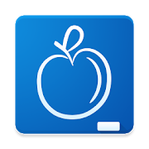
iStudiez Pro - An organizer in which students can set up class schedules, homework, class assignments, and daily schedule.
Devices: iOS 10.0 or later, Android 4.1 and up and PC Windows 7-10, MAC OS X 10.7 or later
Cost: $2.99
Download from Apple App Store, Google Play Store, and iStudiez Pro website; https://www.istudentpro.com/
Rating: iOS 4.1, Android 4.2
Comment: A nice organizer app for setting up class schedule, homework and other assignments. You can also share your schedule with other users.

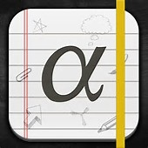
inClass - Organize your schedule, courses, and semesters
Device: iOS 7.1 or higher,
Cost: Free
Download from the Apple App Store
Rating: 3.5 out of 5

MyStudyLife - This is an app that focuses on getting yourself organized by creating an interactive calendar, online to-do lists, and it provides you with reminders for due dates and tests.
Devices: iOS 8.0 or later, Android 4.3 and up, and PC Windows 8 – 8.1
Download from Apple App Store, Google Play Store Store, and online at app.mystudylife.com
Rating: iOS 4.6, Android 4.3

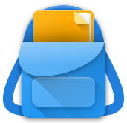
School Assistant - Keeps your routine organized; such as schedules, courses, homework, exams, etc.
Device: Android varies with devices
Cost: Free
Download from Google Play Store
Rating: 4.2 out of 5

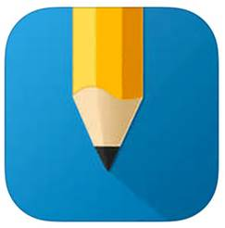
myHomework - Keep track of homework and projects, can enter by semester schedule, tracks homework, tests, projects and lessons.
Devices: iOS 8.0 or later, Android varies with device, PC Windows 10 version 10240.00.
Cost: Free
Download from both Google Play Store and the Apple App Store
Rating: 4.5 out of 5

RescueTime - This is a program that you can download on to your computer that allows you to track the amount of time you spend online and on social media sites throughout the day. This program helps you understand your daily habits so you can maximize productivity while studying or typing papers.
Devices: Android 4.0 and up
Cost: Free
Download from Google Play Store
Rating: 4.0 out of 5

Google Task - Create and edit task in Gmail on the computer and through mobile web browsers.
Devices: any device that has an internet browser
Cost: Free
Download from Google Chrome Store
Rating: 3 out of 5
Comment: Not a true App. One of the many Google Tools (Apps) to use with a Google Account. Not available for use on a phone without an internet browser.

Education

Syracuse University Mobile - Syracuse University in the palm of your hand! This app delivers a wealth of current information and services about SU
Devices: iOS 9.0 or later, Android 4.1 and up
Cost: Free
Download from the Apple App Store and Google Play Store
Rating: 4.8 out of 5

Blackboard Mobile Learn - Makes it easier for you to keep up with your courses by letting you access them whenever and wherever you want.
Devices: iOS or later, Android 4.0 and up
Cost:
Download from
Rating:

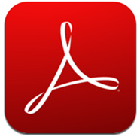
Adobe Reader - Easily access, manage, and share a wide variety of PDF types
Devices: iOS 9.0 or later, Android varies with device.
Cost: Free
Download from Apple App Store, Google Play Store, and Adobe website.
Rating: 4.3 out of 5

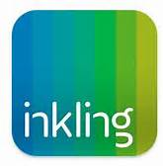
inkling - Digital College Textbooks-- Place to buy them and use on iPad
Device: iOS 9.0 or later
Cost: App is free must purchase the textbooks
Download from the Apple App Store
Rating: 2.3

Formulas - Formulas for Calculus - A simple, easy to use, easy to navigate collection of the most important formulas and topics for college students.
Devices: iOS 10.3 or later
Cost: Free
Download from Apple App Store
Rating: 3.5 out of 5

Calculus Formulas - The app lists all the important Calculus formulas
Devices: Android 3.0 and up
Cost: Free
Download at Google Play Store
Rating: 4.1 out of 5

File Storage

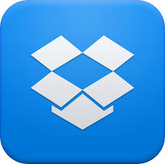
Dropbox - Back up, Save, and Share your photos, docs, videos, and other files
Device: iOS 9.0 or higher
Cost: Free
Download from Apple App Store
Rating: 3.5 out of 5

Dropbox - Back up, Save, and Share your photos, docs, videos, and other files
Device: Android 4.1 and up
Cost: Free
Download from Google Play Store
Rating: 4.4 out of 5

Accessibility

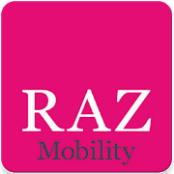
Raz Mobility -The app provides a selection of great applications for individuals who are blind, visually impaired, deaf, and hard of hearing, have a speech impairment or have a mobility disability.
Devices: Android 4.1 and up
Cost: Free
Download from the Google Play Store
Rating: 5.0 out of 5 (only one rated so far)

Tecla Access - Tecla is a set of tools that provides access to mobile devices, such as smartphones and tablets, for those who are unable to manipulate them due to disease or disability.
Devices: Android 2.0 and up
Cost: Free
Download from Google Play Store
Rating: 4.2 out of 5

