Creating Accessible PDF Documents

Most PDF files are created in another program such as Word, PowerPoint, or other word processors applications, and then converted to a PDF.

Creating an Accessible Word Document
- Create the Word document using the desired formatting, graphics, styles, and paragraph spacing.
- Give the document a title/name that makes sense. Include the word “Form” in the file name or document title
Make sure the file is accessible by paying attention to the document’s heading structure, image Alt – Text, and descriptive link text.

Header Structure:
- Proper headings - Having a uniformed heading structure in a Word document is one of the most important accessibility considerations.
  - Heading structure hierarchy is Heading Level 1 to Heading level 6
  - Screen reader users are able to navigate documents by Heading Levels
  - Use the Heading Styles section provided in the Home Ribbon of Word
    - Screen readers do not pick up or recognize “free style headings” (bolded, underlined, italicized, or increased font sized text) created by the Word document author.
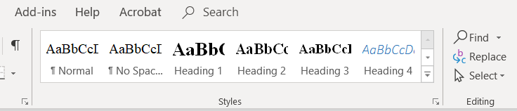
Figure 1 Heading Styles Section

To insert a Header:
- Type the desired text
- Focus your cursor anywhere on that line of text
  - Press Control + ALT + 1 for Heading level 1
    - Control + ALT + 2 for Heading level 2
    - Control + ALT + 3 for Heading level 3
    - Control + ALT + 4 for Heading level 4
    - Control + ALT + 5 for Heading level 5
    - Control + ALT + 6 for Heading level 6
Or
  - From the Styles section of the Home Ribbon click on the desired Heading level
- After setting the Heading level, press Enter to continue typing and editing your document.

Alternative Text for Images
Alternative Text for Images - Alternative text provides a textual representation of the content or function of an image in a Word document. Alternative text should be:
- Accurate and Succinct—no more than a few words are necessary; rarely a short sentence or two may be appropriate.
- Do not be redundant—do not provide information that may be in the surrounding text.
- Do not use phrases such as “image of “… or “graphic of …” screen readers identify images and inform the user of their presence.

Adding Alternative Text
- Bring focus to the picture or graphic by left clicking on it
- Open the properties with right click
Figure 2 Edit Alt Text or Format Picture Options
- Click on Edit Picture or Edit Alt Text (Office 2019)
    - Office 2016 and lower, select Format Picture
    - Then Alt – Text option (3rd from the left)
Figure 3 Location of Format Picture Option
  - Title – Enter a title for the graphic (will not be read by screen reader)
  - Description - Enter in an accurate and succinct short sentence description of the image/graphic (screen readers do read the description you enter)
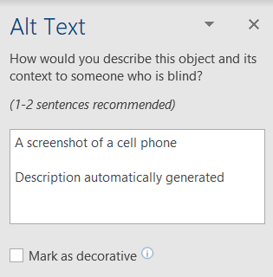
Figure 4 Alt Text Description Box

Descriptive link text
Descriptive link text - Use descriptive text to identify links. Avoid using ambiguous descriptions such as “click here” or “here”
To add a descriptive link:
- Paste the link directly into your Word document
- Right click on the link, and select Edit Hyperlink
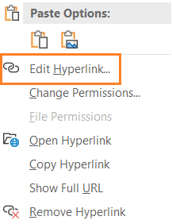
Figure 5 Edit Hyperlink Option
- From within the Edit Hyperlink dialog:
  - Make sure the URL is displayed in the Address edit box (bottom center of dialog)
  - Locate the Text to Display edit box (Top center of dialog) and enter the text description
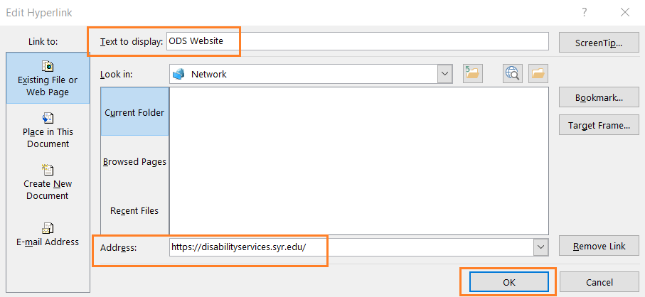
Figure 6 Edit Hyperlink Dialog Box
- Select the OK button

Check Accessibility
- Open the Backstage view (File menu or ALT + F)
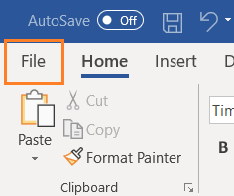
Figure 7 File Menu
- Select the Info tab

- Locate the Check for Issues button and click it
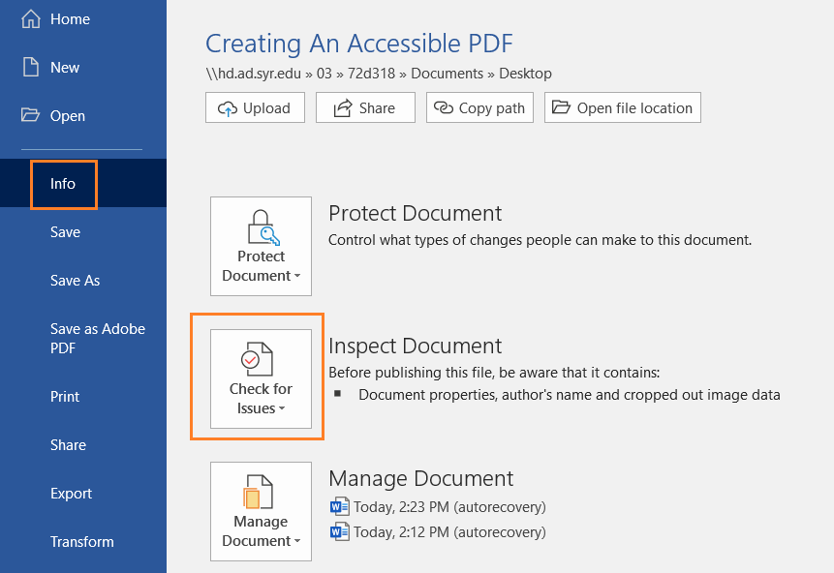
Figure 8 Info Menu
- Select and click on Check Accessibility
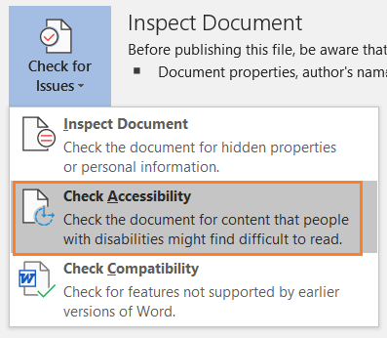
Figure 9 Check Accessibility Option
  - Results are shown in a panel on the right-hand side of the screen
  - Results are labeled as to what the problem is. Example: Missing Alt-text, too many blank spaces

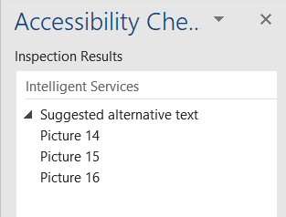
Figure 10 Accessibility Checker Results
When finished editing your Word document, Save it.

Creating an Accessible PDF
With the Word document you have just created still open:
- Open the Backstage of Word (File menu or ALT + F)
Figure 11 File Menu
- Select the “Save as Adobe PDF” option (ALT + F + Y2)
  - You may get a message to save the Word document
  - Activate the OK button
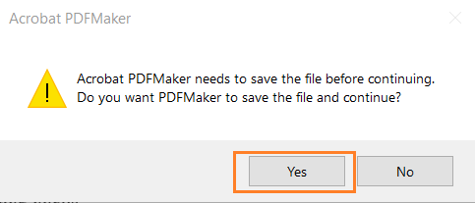
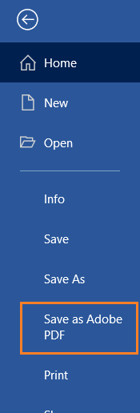
Figure 12 Save as Adobe PDF

- Save As dialog opens
  - Locate and activate the Options button (near bottom of dialog box)
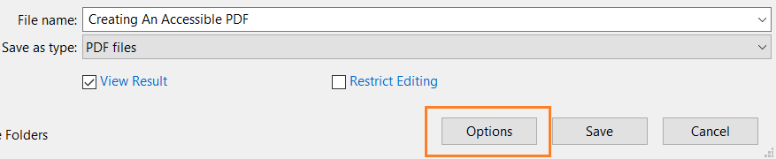
Figure 13 Options Menu Button
- Adobe PDF Maker dialog opens
  - PDF Options section check the following boxes:
    - Convert document information
    - Enable Accessibility and Reflow with tagged Adobe PDF
    - Create Bookmarks
    - Convert Word Headings to Bookmarks
  - Page range section select the desired options radio button
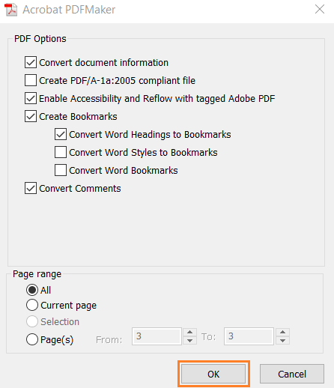
Figure 14 Options Menu
- Activate the OK button
- Activate the Save (ALT + S)

